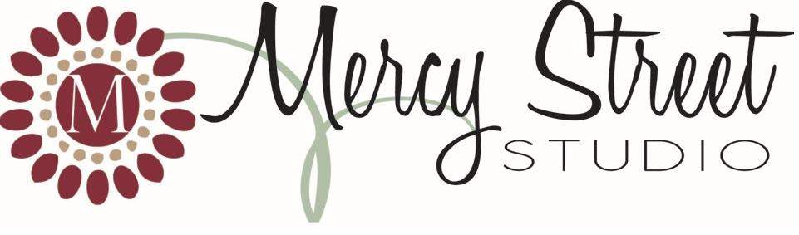
2013 Homeschool Photo Event
Student Name: _____________________________________Parent’s Name: ____________________________
Address: ___________________________________________________________________________________
City: _______________________________________ State: ____________ Zip: __________________________
Email: __________________________________________________ Phone: _____________________________
Are you a fan of our Facebook Page (Mercy Street Studio by Erin Moore)? Becoming a fan will allow you to see a sneak peak of photos and keep up on specials and events. Yes No

Print Packages
Package A ($39) | Package B ($19) | Package C ($9)
(1) 11x14 | (1) 8x10 | (2) 5x7
(2) 8x10 | (2) 5x7 | (8) Wallets
(2) 5x7 | (4) 4x6
(4) 4x6 | (8) Wallets
(8) Wallets

Additional Prints
Quantity | Item | Price | Total
 | (8) Wallets | $5 | $
 | (2) 4x6 | $5 | $
 | (1) 5x7 | $5 | $
 | (1) 8x10 | $10 | $
 | (1) 11x14 | $15 | $
If you wish to have the photos shipped to your home address, add $5 for shipping,  otherwise, photos will be sent to Union School House for pick up. |  |  | $
Please be sure to include $10 sitting fee. |  | Total | $
Payment
Cash Check (check #____________) Please make checks payable to ERIN MOORE & write student’s name in memo.

Additional Poses
Sibling portraits are available upon request. Please note that a separate order form must be filled out for each desired pose.

The Boring Stuff
I hereby grant Erin Moore and/or Mercy Street Studio the absolute and irrevocable right and permission with respect to the photographs that he/she has taken of me and/or my minor child:
a) To copyright the same in Erin Moore and/or Mercy Street Studio’s name, or any other name that he/she may select;
b) To use, re-use, publish and re-publish the same in whole or in part, separately or in conjunction with other photographs, in any medium now or hereafter known, and for any purpose whatsoever, including (but not by way of limitation) illustration, promotion, advertising and trade, and;
I hereby release and discharge Erin Moore and/or Mercy Street Studio from all and any claims and demands ensuing from or in connection with the use of the photographs, including any and all claims for libel and invasion of privacy. This authorization and release shall inure to the benefit of the legal representatives, licensees and assigns of photographer Erin Moore and/or Mercy Street Studio, as well as the person(s) for whom he/she took the photographs.
I WAIVE, RELEASE, AND DISCHARGE from any and all liability, including but not limited to, liability arising from negligence or fault of the entities or persons released, for my personal injury, disability, death, property damage, or actions of any kind which may hereafter occur to me as a result of participation in a photo session by photographer Erin Moore and/or Mercy Street Studio.
I have read the foregoing and fully understand the contents hereof. I represent that I am the parent/guardian of the above named child/children. For value received, I hereby consent to the foregoing on his/her behalf.
Signature: _______________________________________________ Date:____________________________

